**Stakeholder Mapping**

Stakeholder mapping is a visual representation of people or groups that have a stake in a project, product, or idea. It's a strategic process that helps identify stakeholders, understand their influence, and develop a plan for managing them.

**Advantages:**

**1. Find out who has the most influence**

When you build a stakeholder map, you can easily see who will have the highest level of influence over a project, whether it’s the CEO or a project manager.

**2. Focus on those who benefit most**

Stakeholder maps help you see who will benefit most from the end product so you can focus on marketing to that person for resources.

**3. See where resources are most plentiful**

Stakeholder maps often illuminate who has constraints and limited influence and who has more resources, so that you can put the right people on your project team.

**4. Have a game plan**

Overall, a stakeholder map gives you a good idea of who you’re trying to satisfy when building your product or project.

**Internal stakeholders**

Internal stakeholders are people on your team who are participating in building your product or delivering a project. Their level of engagement may vary but they all have an influence because they are a part of your organization. Here’s what a list of internal stakeholders might look like:

* CEO / C-level executive
* Product owner
* Project manager
* Agencies / Consultants
* Designer
* Developer

**External stakeholders**

External stakeholders are those who will be impacted by your project and product, though they don’t directly participate in working on it. Here are examples of external stakeholders:

* Customers
* Partners
* Shareholders/Investors
* Suppliers
* Government agencies
* Community members

**Stakeholder matrix to prioritize your project stakeholders**

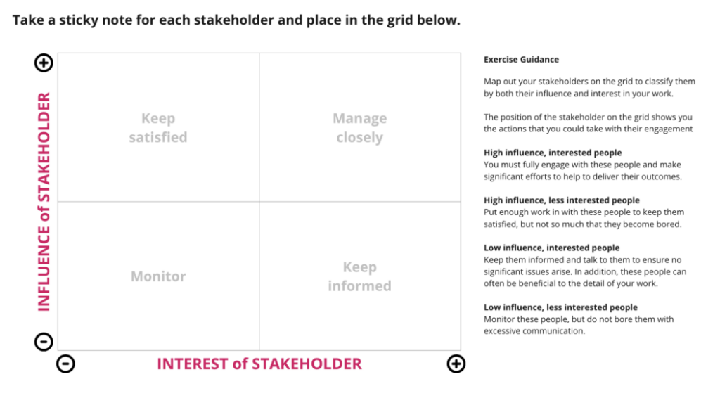

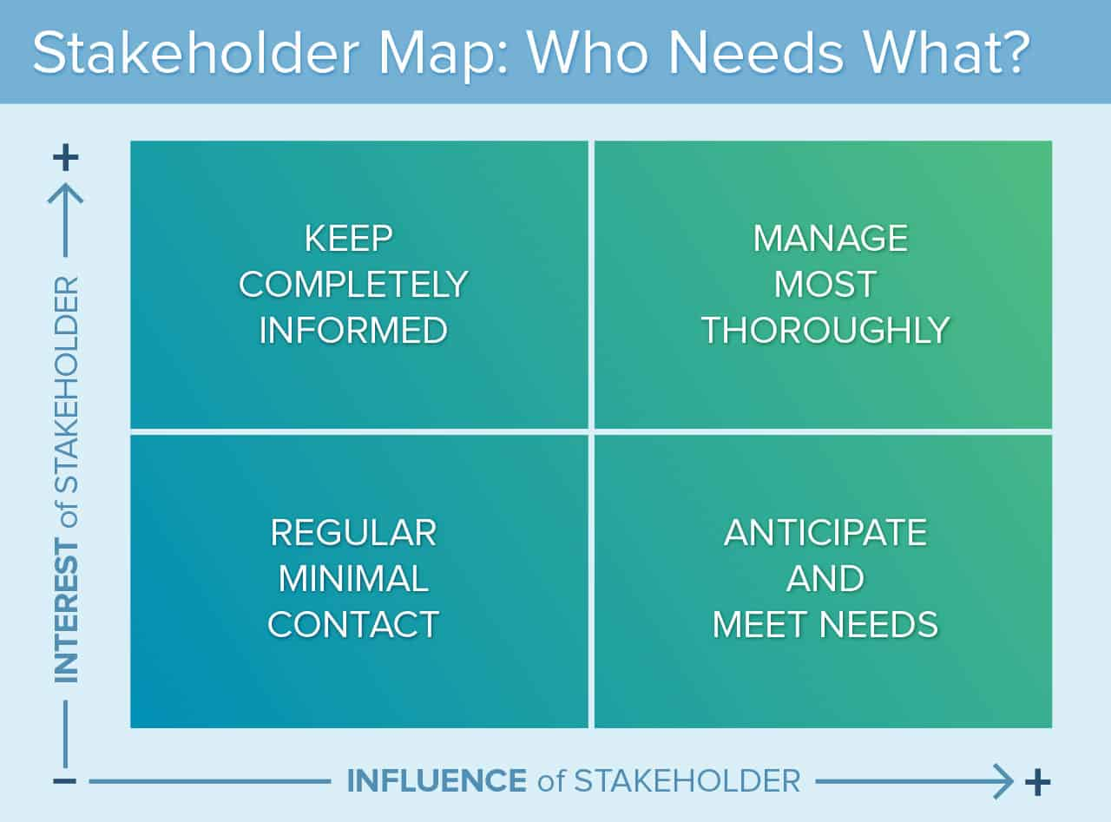

**KPI`s**

* On-Time Delivery Rate

Measurement: (Number of projects/features delivered on time / Total number of projects) x 100

Target: 90%

* Code Quality

Measurement: Code coverage percentage, number of bugs reported post-release

Target: 80% code coverage, <5 critical bugs per release

* Team Velocity

Measurement: Story points completed per sprint

Target: Consistent or improving trend over time

* System Uptime/Availability

Measurement: (Total uptime / Total time) x 100

Target: 99.9% uptime

* Mean Time to Recovery (MTTR)

Measurement: Average time to resolve critical issues

Target: <2 hours for critical issues

* Technical Debt Ratio

Measurement: (Cost to fix issues / Cost to develop the system) x 100

Target: <25% and decreasing over time

* Sprint Burndown

Measurement: Remaining work vs time in sprint

Target: Consistent completion of sprint goals

* Customer Satisfaction Score (CSAT)

Measurement: Survey results from internal/external customers

Target: >4.5/5

* Employee Satisfaction and Retention

Measurement: Employee satisfaction surveys, turnover rate

Target: >80% satisfaction, <10% annual turnover

* Innovation Metrics

Measurement: Number of new ideas implemented, percentage of time allocated to innovation

Target: 2 major innovations per quarter, 20% time allocated to innovation projects

* Cost Efficiency

Measurement: Actual project costs vs budgeted costs

Target: Within 10% of budget

* Time-to-Market

Measurement: Time from project initiation to production deployment

Target: 10% reduction year-over-year